FAWCO Friendship Quilt 2014
You all know by now that we have a new Target Program: Women’s Rights. The rights we enjoy in developed countries open to us “a world of possibilities” – choices of all we care to achieve. Our foremothers in the 19th century, deprived of a political presence, often used quilts to express their aspirations for social change, and raise money to support what they believed in. The names of many traditional blocks (Temperance T, 54-40 or Fight, Tippecanoe and Tyler Too) illustrate causes they supported.
What rights would you fight to protect?
Here’s an extremely simple block, Endless Stairs, which reminds us that we can never stop working for women’s rights and for positive change.
http://quilting.about.com/od/blockofthemonth/ss/endless-stairs-quilt-block.htm
This makes a block 8.5” square with seam allowance (8” finished size). In case the link doesn’t work, here’s what you do:
- Cut a strip of medium or dark fabric 3” X 19”. Cut a strip of light fabric 2” X 19”. Seam together on the long edge to make a strip 4.5” X 19”. Press the seam toward the dark side. Check that your strip really is exactly 4.5” wide!
- Cut from this strip 4 squares, each 4.5”.
- Lay out the squares in 2 rows of 2 with the light strip towards the top. Rotate the top right and lower left ones a quarter turn so the light strip is to the left.
- Sew the squares together. The resulting block should measure exactly 8.5”.
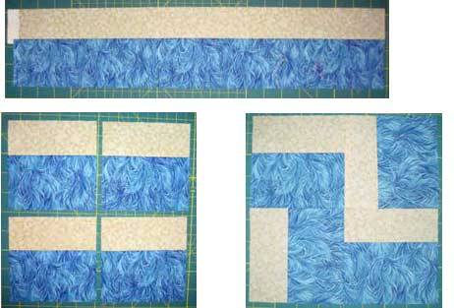
- Using an archive-quality permanent pen (I use Pigma 0.5mm, please DON’T use Sharpies), sign your name and the cause you think is worth a fight. Put it in one of the light strips so we can see it! The name of your club would be nice too.

Please use 100% cotton fabric, batiks if you’re feeling generous, and your favorite color.
Deadline: October 10, 2013
Questions? rl.zollner@gmx.net
Thanks for participating!

